2. string variable size never smaller than the string. Otherwise we are getting error.
3. We can’t copy a string with = operator. For this we have to use strcpy() belongs to <string.h>
a=10;
b=1.2;
c=’X’;
d=”abc”; 🡺 Error
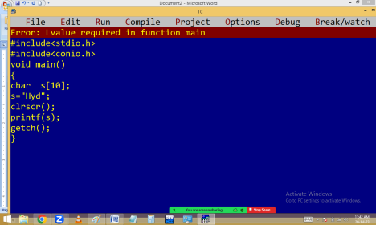
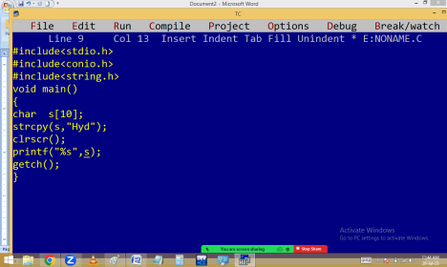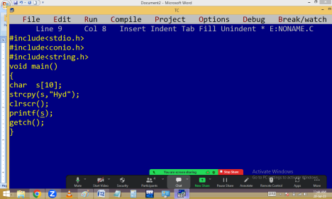
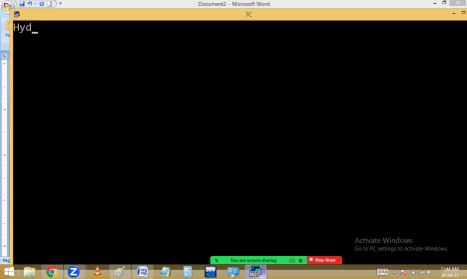4. we can’t compare two strings using == (comparison operator). We have to use strcmp() available in string.h
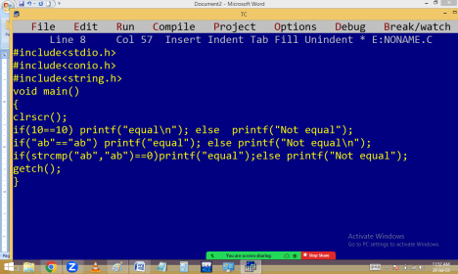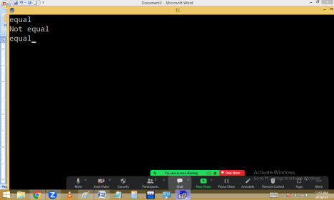
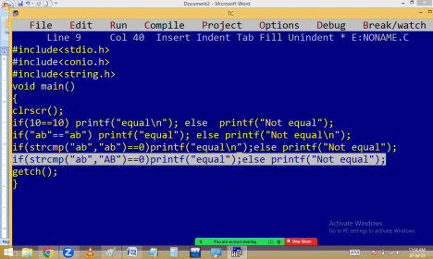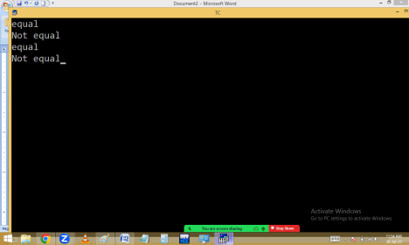
OPERATORS
Operator is a special symbol designed for a particular task [ work ]. C comes with 44 operators and 14 separators. Operator works on operands.
Based on no of operands participating in operation, the operators divided into 3 types.
1.Unary operator: Require one operand.
Eg: +5, -5, a++, a--, ++a, --a, !a, ~a, sizeof(a),…
2.Binary operators: Require two operands. Eg: a+b, a*b, a>=b, a!=b, a<<b,…..
3. Ternary / Conditional operator [ ? : ] Require three operands.
Eg: 5 > 3 ? “5 big” : “3 big”;
condition part ? true part : false part ;
Based on operation, the operators divided into several types.
1.Assignment operator [ = ]: It copies the value on its right side into the variable on its left side. Left side operand should be a variable. i.e. expressions or
constant not allowed on left side. String copy also not allowed.
Eg:
a=10;
b=1.2;
c=’X’;
d=”xyz”; 🡺 Error because of string
e = f = g = 10;
10=20; 🡺 Error because of 10 is a constant
a = 10+20; 🡺 a becomes 30
10+20=30; 🡺 Error because of 10+20 gives 30 which is a constant.
